Course Methods Year 12 test one 2022

Student name: ________________ Teacher name: ________________

Task type: Response

Time allowed for this task: _____40______ mins

Number of questions: ____8_______

Materials required: No calculators nor classpads allowed

Standard items: Pens (blue/black preferred), pencils (including coloured), sharpener, correction fluid/tape, eraser, ruler, highlighters

Special items: Drawing instruments, templates, NO notes.

Marks available: ___40___ marks

Task weighting: _10___%

Formula sheet provided: Yes

Note: All part questions worth more than 2 marks require working to obtain full marks.

Q1 (3, 4 & 3 = 10 marks)
Differentiate the following:

- and simplify

- do not simplify

Q2 (4 marks)
Determine the equation of the tangent to at

Q3 (5 marks)
Determine the coordinates of the stationary points and their nature for . Justify.

Q4 (3 marks)
The displacement of a body from an origin O, at time seconds, is metres where

Determine the velocity and the displacement of the body when the acceleration is zero.

Q5 (4 marks)
Consider the function which is graphed below.
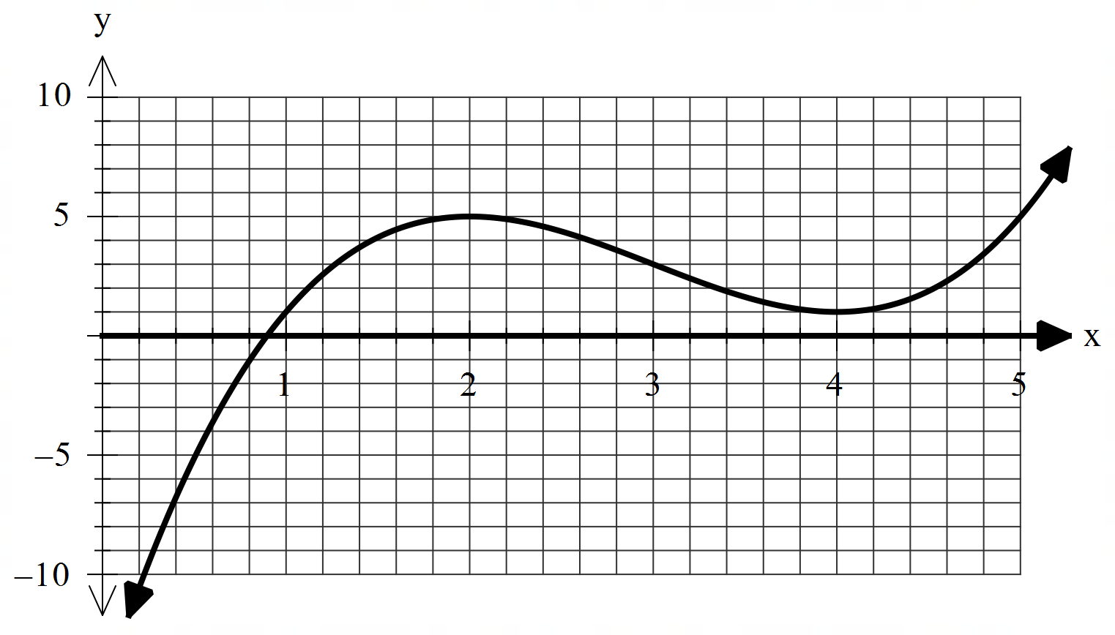

On the axes below, sketch the gradient function indicating on your sketch the location of any stationary points and any inflection points for . (labelled)

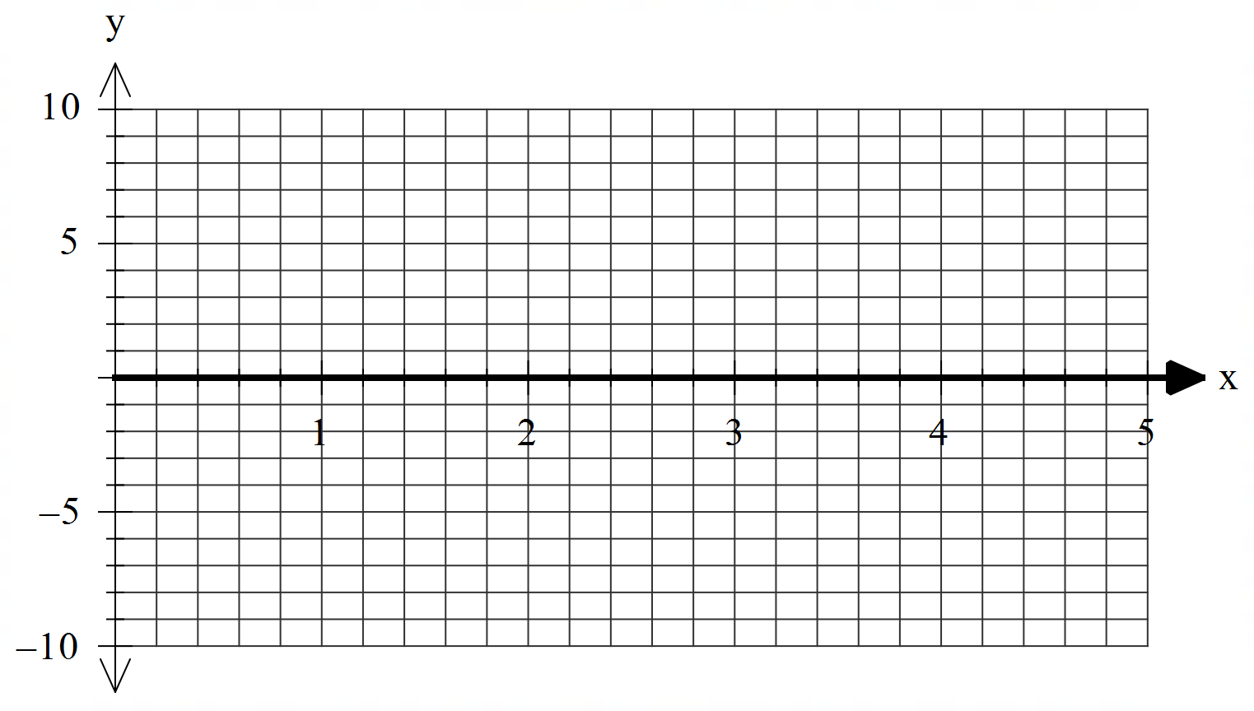
Q6 (2 & 3 = 5 marks)
Consider the function where .
- Using the increments formula (small change) determine an approximate value for .

- The volume of a sphere of radius metres is given by . Using the increments formula determine the approximate percentage change in volume for a 3% change in the radius.

Q7 (4 marks)
Let equal the number of hectares that a farmer will use to grow corn one season. The amount of corn to be harvested per hectare is given by kg for . Using calculus determine the number of hectares that should be used to maximise the amount of corn produced.

Q8 (5 marks)
Let the cost, $, to make items in a factory be given by dollars. Using calculus show that the minimum average cost per item is equal to the marginal cost at this number of items.

